a. What is the URL of your assignment?

URL: /site/wwwroot/project3 ([https://CMST385-tdao5.azurewebsites.net](https://cmst385-tdao5.azurewebsites.net) )

b. What issues or challenges did you face completing this project?

none

c. What software programs did you use to create this project?

Visual Studio Code

d. Where did you get your images from?

From Google.

e. Include the validation information for your HTML5 and CSS validation you completed for this assignment.

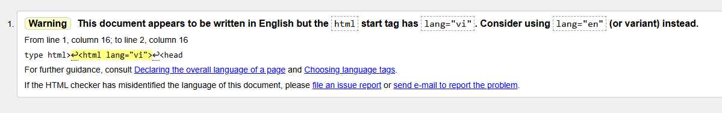

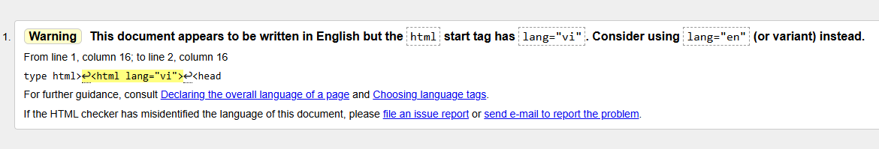

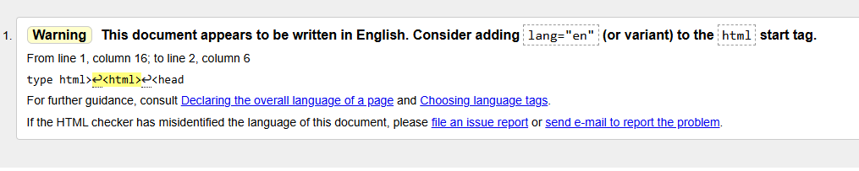

Note: The text contains Vietnamese accent marks. To ensure they display correctly when opened, I need to declare the language as "vi" instead of "en."

